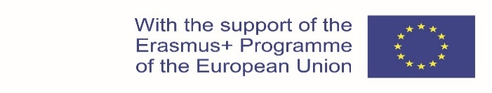
Project: KA203 - Strategic Partnerships for higher education agreement no. 2020-1-PL01-KA203-081905
Innovative education for students of medical and health sciences, resulting to better adapt the didactic offer to the health needs of pregnant and post-pregnant women (INSTEpp)

STUDENT APPLICATION FORM

- Student’s personal data

- Family name

- First name

- Gender | F (female)  M (male)
- Date of birth

- Nationality

- Passport /ID Number

- Personal E-mail address | E-mail: ………………@………………………
- Additional E-mail address to be used in case of need (e.g. Erasmus office address, etc.) | E-mail: dgogol@uni.opole.pl

- Other personal information

- Current address  (valid until ../../..) | Street: ………………………………………………..  City: …………………………………………………  Postal code: ………………………………………….  Country: …………………………………………….
- Tel number of current address | +…/……/……………..

- Student’s Home University Country: Poland

- Name | University of Opole
- Erasmus code | PL OPOLE01
- Faculty/Department

- Subject Study Area

- Erasmus Contact person (Name/Surname) | Daria Gogol
- E-mail/Tel. of Contact person | E-mail: dgogol@uni.opole.pl  Tel. : +48 77 452 7353

I confirm that the information provided in this application is true and accurate. In case I have to withdraw from the course, I will inform my home coordinator for the INSTEpp Project as soon as possible, and no later than 9th^{t} May 2022. | I endorse this application on behalf of my home coordinator for the INSTEpp Project.  Contact person’s full name: Daria Gogol  ...........................................................................  Date:............................................................…..
Student’s confirmation
full name and surname: ..................................

Signature: .........................................................

Date:............................................................…..

